Camera Trap Images Manual Classification System

Instruction Manual

1 Functional description
After specifying the storage path of the camera trap images and the storage path of the classification label file (.csv file), this software can automatically read the images in the specified directory and display it in the user interface. Users can set the species label of image according to the image content by clicking on the corresponding button and system will automatically copy the image to the corresponding folder and add the record to the .csv file. The software supports user-defined labels, and users can customize the labels on the buttons as needed, which has better flexibility.

2 operating manual
1. Run the software system (Fig.1)
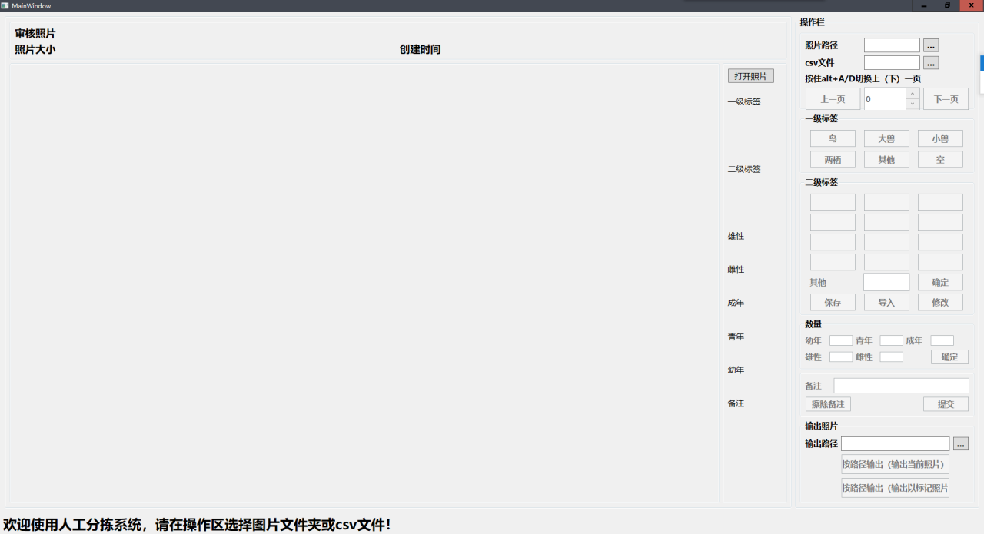
Fig.1 System startup interface
2．Select images storage path(Fig.2)
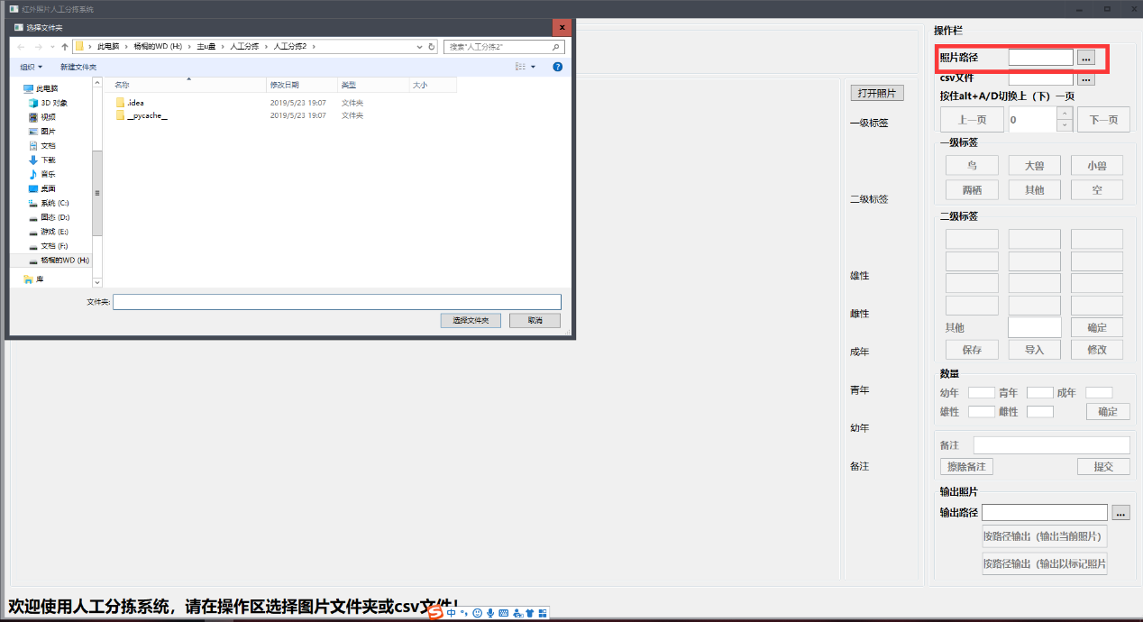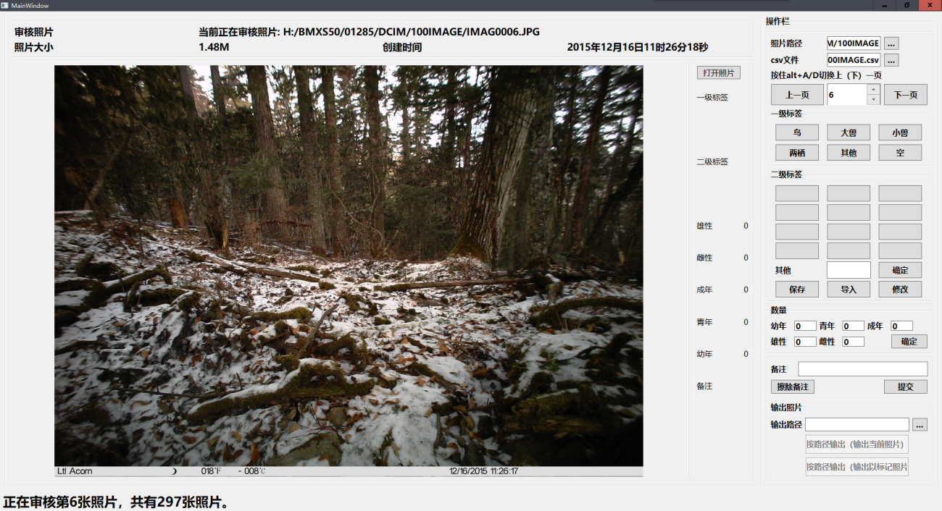
Fig.2 Select images storage path
3．Select the output path of classification label file (.csv) (Fig.3)
Fig.3 Output path.csv file
4. Use the navigation buttons to browse the image(Fig.4)
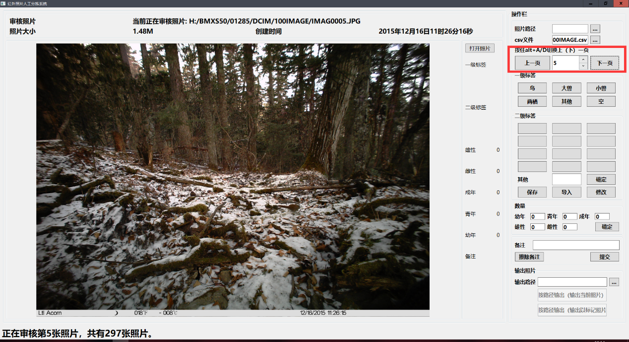
Fig4. Navigation buttons

5. Use a first-level label to mark images, including birds（鸟）, large beasts（大兽）, small beasts（小兽）, amphibians（两栖）, other（其他） and empty（空）（Fig.5）.
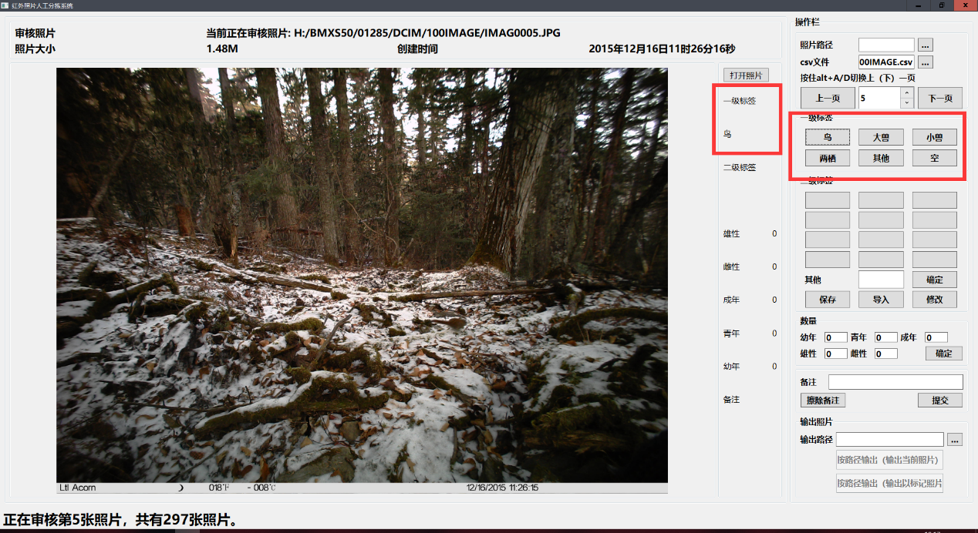
Fig.5 First-level label
6. Label images with species(Fig.6), label names can be customized by the user (Fig.7)
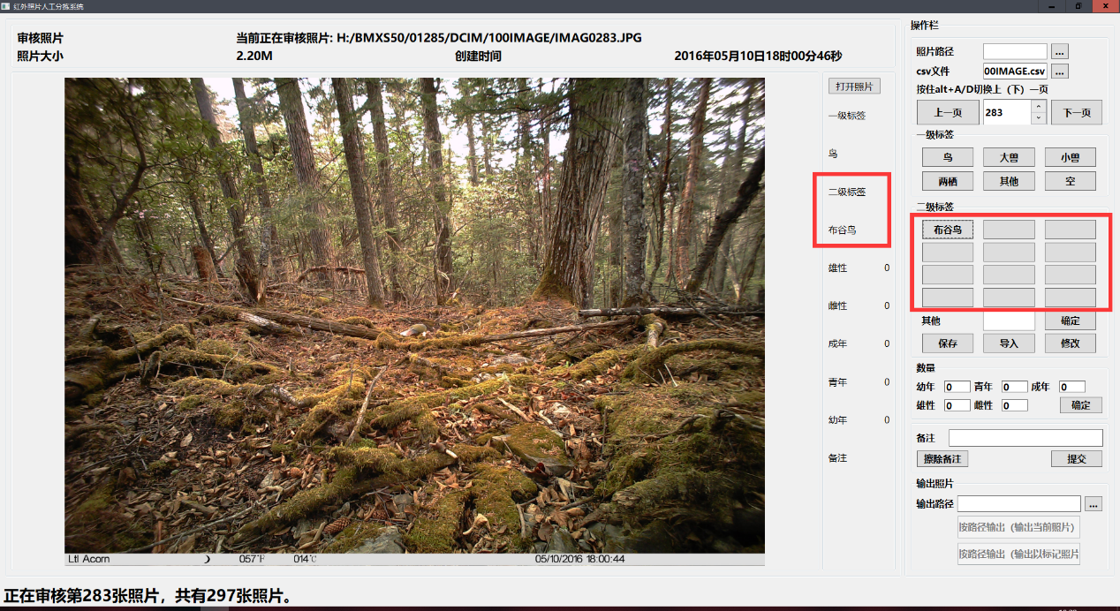
Fig.6 species label
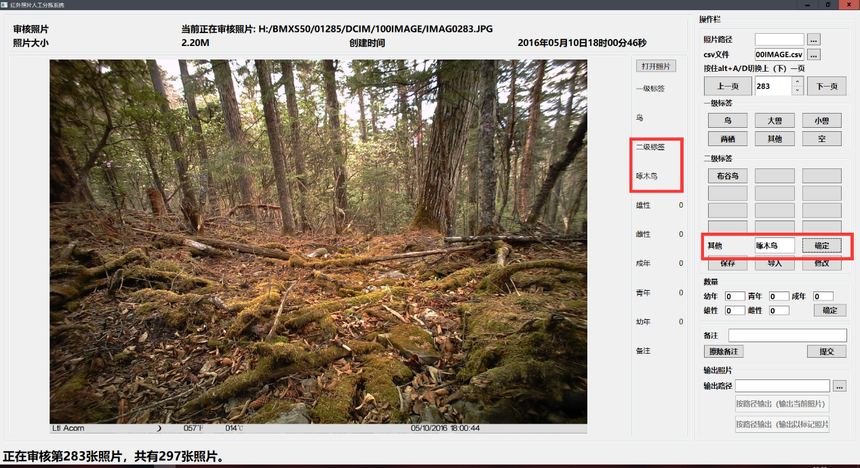
Fig.7 User-defined label
7. Save user-defined labels to .csv file(Fig.8)
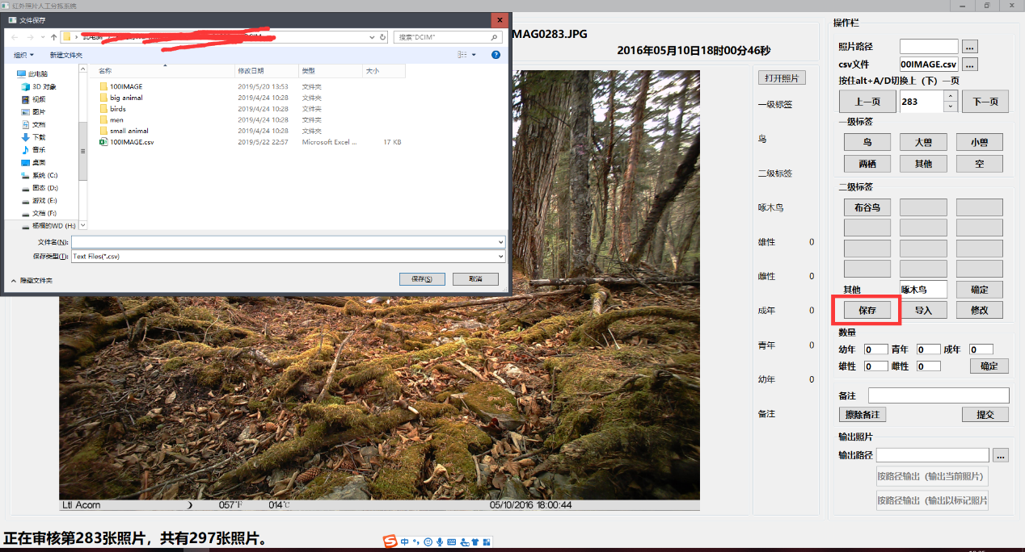
Fig.8 Save user-defined labels
8. Load the species labels from the .csv file(Fig.9)
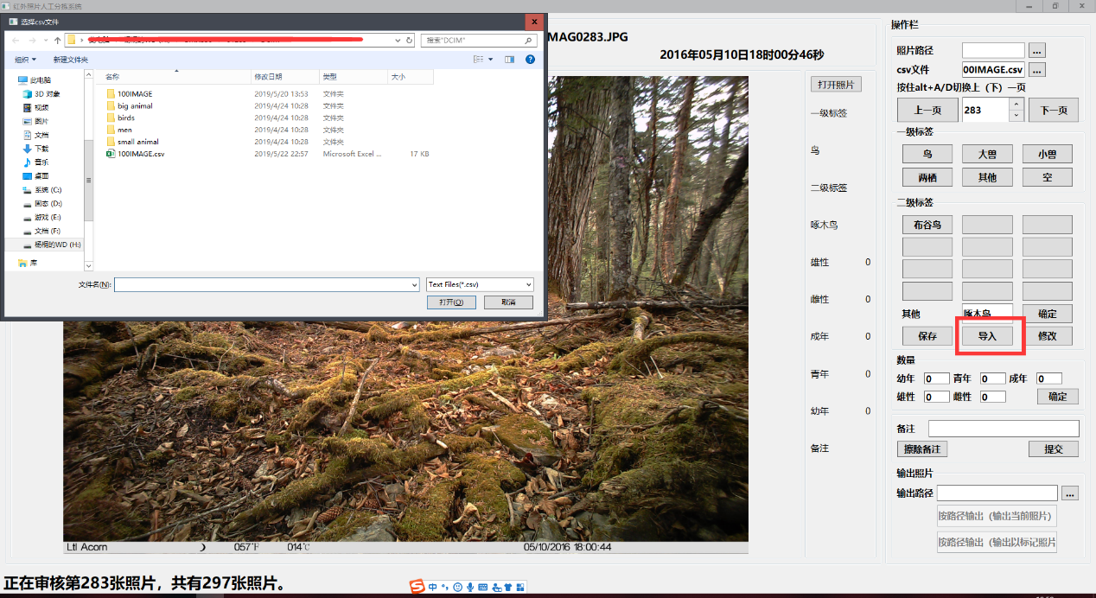
Fig.9 Load the species labels from the .csv file
9. Modify species labels(Fig.10)
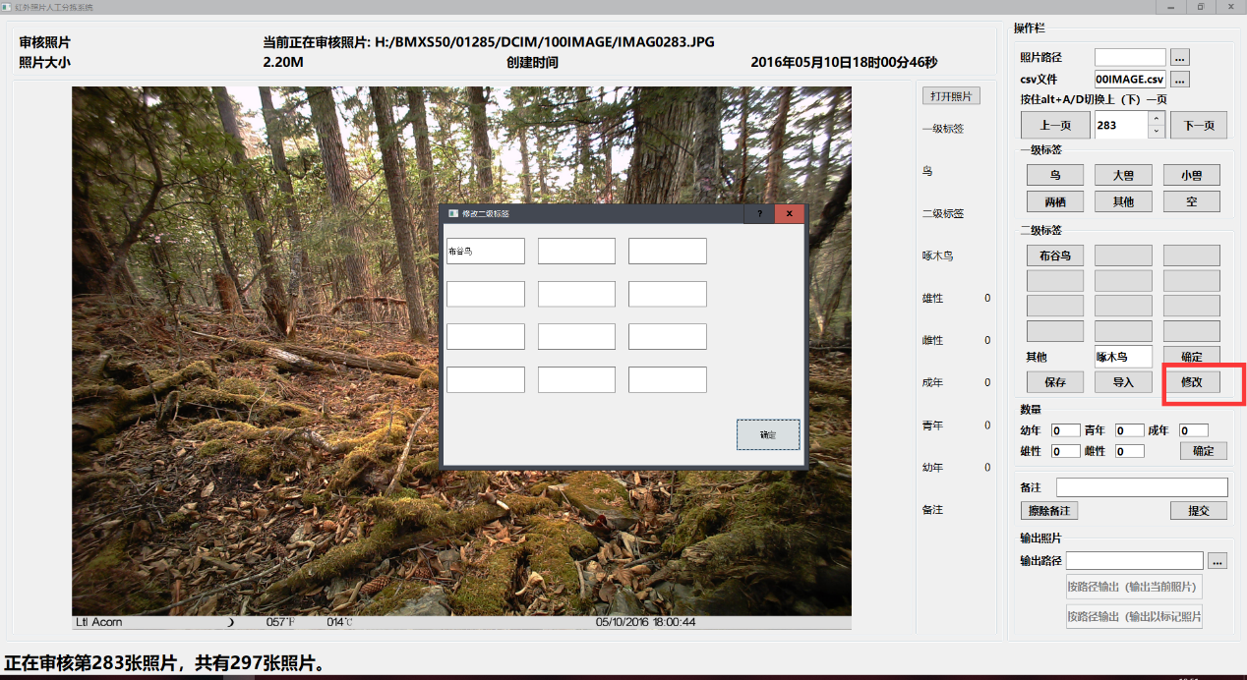
Fig. 10 Modify species labels
10. Number of registered species(Fig.11).
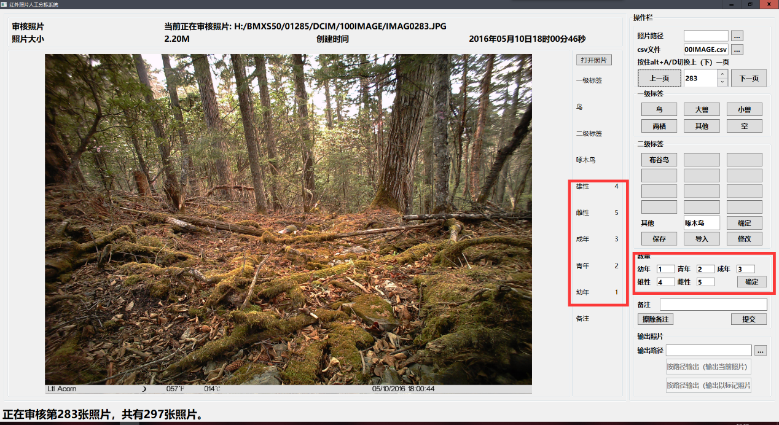
Fig.11 Number of registered species
11. Add image comment information to a .csv file(Fig.12).
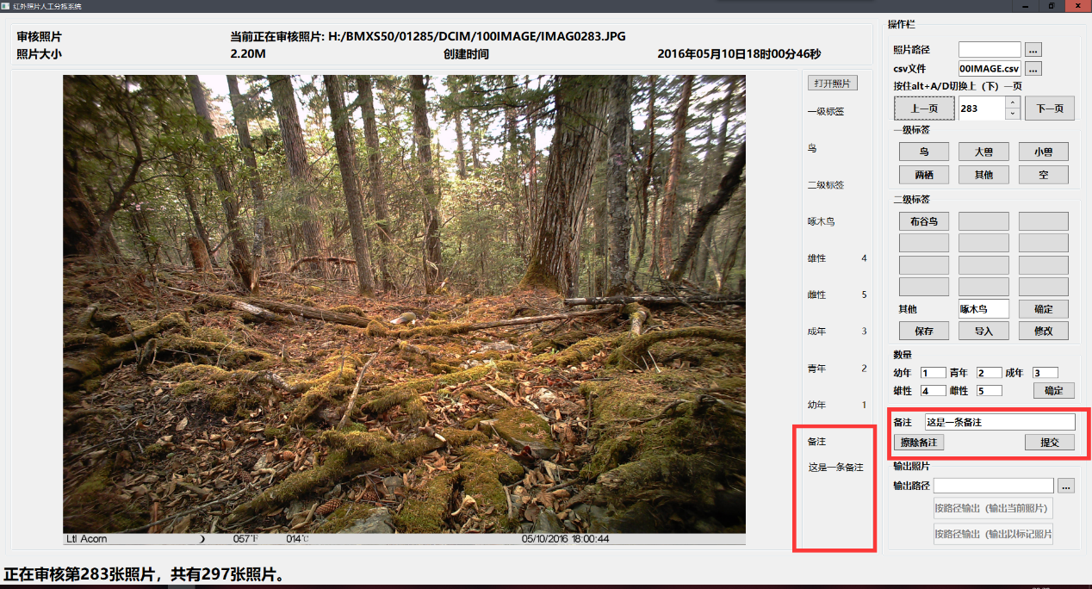
Fig.12 Add image comment information to a .csv file
12．Select image output path (Fig. 13)
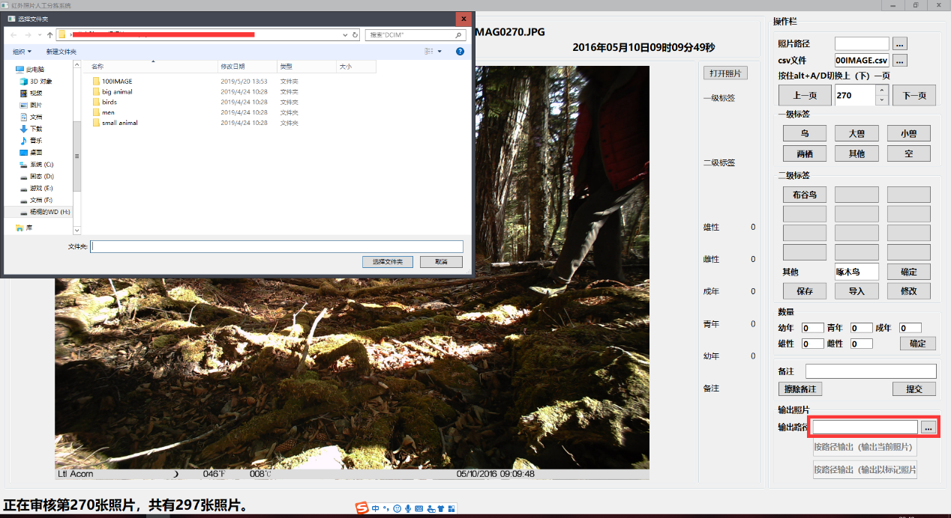Fig.13 Set image output path
13. Copy the image to the specified directory(Fig.14)
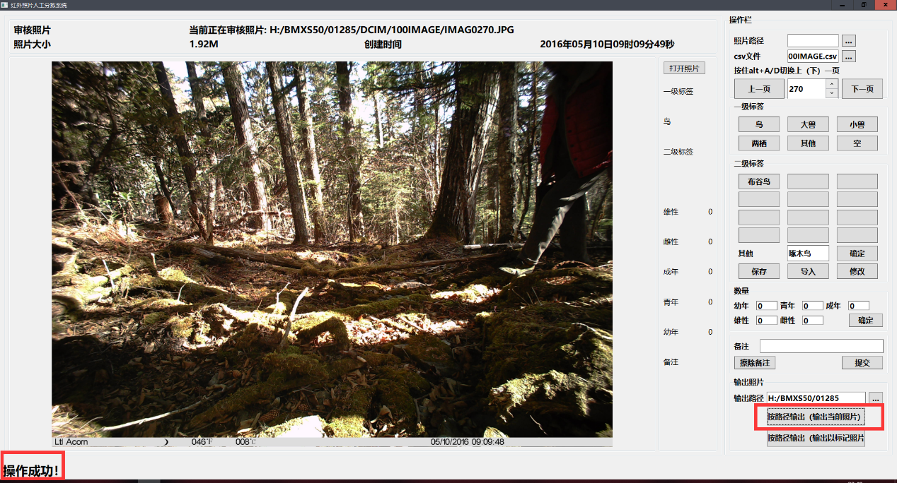
Fig.14 Copy the image to the specified directory
14. Save image tag information to a .csv file(Fig.15)
Fig.15 Save image tag information to a .csv file

